**CIS-350  
Infrastructure Technologies  
Group Lab 3 Report**

**Group 7:** Rami Mohamed, Simona Sofronova, Brody Hayden, and Adam A.

**Though this is a Group Lab 3 Report, you must work this hands-on Lab 3 individually**. After **you do that, get in groups, discuss and provide answers to the following problems, and submit this report, one per group, to Blackboard. When you work Lab 3 hands-on, you are likely to do better on Test 3 which will cover the operating systems part of the course.**

**You must login to your Ubuntu Linux account on the Mercury server and work all of the commands in file** [[File](https://blackboard.louisville.edu/bbcswebdav/pid-24925443-dt-content-rid-105319143_2/xid-105319143_2)CIS-350-Lab3-Linux Command Prompt(1).pdf](https://blackboard.louisville.edu/bbcswebdav/pid-24925443-dt-content-rid-105319143_2/xid-105319143_2). **If you follow the Lab 3 instructions carefully, you should have all the required directories and files stored in your Linux home directory (/home/your_login_name; for example, /home/jmzura01). After you submit Group Lab 5 Report (the last one), I will log in to the Linux account of every student to check if the hands-on work was done for Labs 3-5. If I do not see any activity you will get 0 out of 50 points. If I see partial activity, you will earn between 0 and 50 points. If I see full activity, you will get 50 points. No excuses please and no makeup work.**

NOTE 1: Linux commands, filenames, options, etc. are **case sensitive**. The vast majority of them is written in **lower case**. For example, filenames John, JOHN, and john represent three different files.

NOTE 2: You should find the answers to all questions below in the [[File](https://blackboard.louisville.edu/bbcswebdav/pid-24925443-dt-content-rid-105319143_2/xid-105319143_2)CIS-350-Lab3-Linux Command Prompt(1).pdf](https://blackboard.louisville.edu/bbcswebdav/pid-24925443-dt-content-rid-105319143_2/xid-105319143_2), document named [[File](https://blackboard.louisville.edu/bbcswebdav/pid-24925466-dt-content-rid-100860246_2/xid-100860246_2)CIS-350 Unix-Linux Features, Commands and Utilities.pdf](https://blackboard.louisville.edu/bbcswebdav/pid-24925466-dt-content-rid-100860246_2/xid-100860246_2), and the recorded demo of Labs 3-5 and on Panopto and/or MS Teams.

1. What command moves you to your home directory from anywhere? **cd**

2. What command displays your working directory? **pwd**

3. What command moves you to the root directory from anywhere? **cd /**

4. What command moves you to the parent directory? **cd** **..**

5. What command displays all files and directories in a long form and includes invisible files? **ls -la**

6. What command displays the contents of file *Chris*? **cat Chris**

7. What command allows you to get the manual on-line help on the *who* command? **man who**

8. What command would you use to sort data in the ascending order coming from file *Names* and redirect (route) the sorted output to file *NamesSorted*? (Watch the lower and upper case!) **cat Names | sort > NamesSorted**

9. Display the content of the directory in a long form. Include invisible files and protect the directory list from scrolling off the screen. 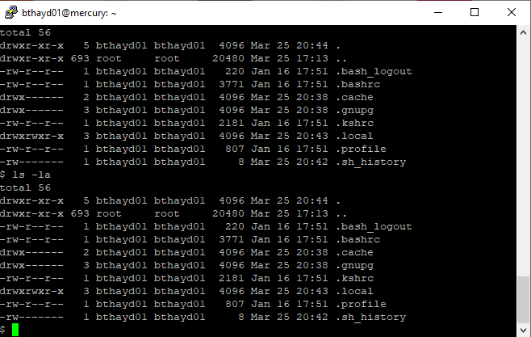

10. What command would you use to open the *pico* editor to create file *Names*? **pico Names**

11. What command would you use to open the *vi* editor to create file *TOM*? **vi TOM**

12. What command would you use to remove the directory *programs*? **rmdir programs**

13. What command is used to change the password? **passwd**

14. What does the command *cat Names > NewNames* do? **It changes the destination of Names to NewNames.**

15. Assume that your home directory is your login directory. Write a command that

(a) creates directory named *john* in your home directory

**mkdir john**

(b) copies all files with extension *cc* from your home directory to the *john* directory

**cp *.cc john**

(c) changes your home directory to the *john* directory

**cd john**

16. Describe briefly what does a command *cat NewNames | sort* do.

**It routes the standard output of NewNames through a sort filter, displaying it alphabetically.**

17. Look at the Linux directory diagram below. Circle the correct absolute path to file *pay*?  
a. /home/jmzura01/programs/prog1 b. /home/jmzura02/letters/prog1  
c. /home/jmzura01/letters/prog1 d. /home/jmzura01/letters/pay  
e. programs/prog1



18. Look at the Linux directory diagram above. You are already in directory *jmzura01*. Circle the correct relative path to file *prog1*?  
a. /home/jmzura01/programs/prog1 b. /home/jmzura02/letters/prog1  
c. /home/jmzura01/letters/prog1 d. /programs/prog1  
e. programs/prog1

19. You have typed the command *ls -al*, pressed Enter key, and the first 10 characters are displayed as

– r w x r w - r - - indicating the file type and file access permissions. Circle the correct access permissions for users in the owner’s group?

a. - b. r w x c. r w - d. r - - e. - - -

20. You have typed the command *ls -al*, pressed Enter key, and the first 10 characters are displayed as

– r w x r - - - - - indicating the file type and file access permissions. Circle the correct access permissions for the owner?

a. - b. r w x c. r w - d. r - - e. - - -

21. You have typed the command *ls -al*, pressed Enter key, and the first 10 characters are displayed as

– r w x r - - - - - indicating the file type and file access permissions. Circle the correct access permissions for all other users?

a. - b. r w x c. r w - d. r - - e. - - -

22. The link (*ln*) command does not copy a file; it merely assigns another name to the same file by creating a new directory entry. Circle the correct answer.

a. True b. False

23. What commercial or open version of Linux you have been using in this lab? Circle the correct answer.  
a. RedHat b. Debian c. Ubuntu d. Gentoo e. X Windows

24. What is the name of the default shell that you have logged into in this lab? Circle the correct answer.  
a. Korn shell b. C shell c. Bourne shell d. Bourne Again shell or Bash shell  
e. Joy shell

25. What command do you use to log off from Linux? Circle the correct answer.

a. CTRL-U b. end c. logout or exit d. finish e. terminate

26. Unix was created in _________________. Circle the correct answer.

a. 1980’s b. 1970’s c. 1960’s d. 1990’s e. 2000’s

27. Linux was created by ________________. Circle the correct answer.

a. Ken Thompson b. Dennis Ritchie c. Bill Joy d. Brian Kernighan  
e. Linus Torvalds

28. Describe briefly which commands did not work and/or which places in the tutorial need improvement/clarification.

______________________________________________________________________________________

____________________________________________________________________________________

____________________________________________________________________________________

____________________________________________________________________________________